Project Blueprint: Olist Marketplace Optimization Dashboard
1. The Business Context
Olist is a major Brazilian e-commerce aggregator & operates as a SaaS (Software as a Service) platform that connects small-and-medium businesses (SMBs) to the country's largest digital marketplaces 🛍️. Olist standardizes the process by handling product listings, payment processing, and logistics fulfillment for thousands of independent merchants.
The Context: Olist is a premier Brazilian e-commerce aggregator that acts as a growth engine for small-to-medium businesses (SMBs). By integrating these merchants into major marketplaces, Olist manages the entire transaction lifecycle—from order routing and payment processing to logistics and customer feedback.
The Business Problem: As Olist scales, maintaining a high-quality customer experience across thousands of independent merchants becomes a massive data challenge. Our objective is to build an Operational Intelligence Dashboard to analyze over 100,000 transactions. This project will identify revenue drivers (GMV), flag critical supply-chain bottlenecks, and segment customer purchasing behavior to help executive stakeholders optimize marketplace health and reduce churn.

The Data Architecture (Schema Overview)
The database relies on a relational schema centered entirely around the orders. To understand how the data flows, we can group the 9 tables into three distinct operational zones:
1. The Transaction Core (The "What" and "When")
- olist_orders: The central hub. Contains order_id, customer_id, and exact timestamps for purchase, approval, carrier shipping, and customer delivery.
- olist_order_items: The cart breakdown. Contains product_id, seller_id, price, and freight_value (shipping cost).
- olist_order_payments: How the order was funded. Contains payment_type (credit card, boleto, voucher) and the number of payment_installments.
2. The Entity Zone (The "Who" and "What")
- olist_customers: Contains customer_unique_id and their zip_code_prefix.
- olist_sellers: Contains seller IDs and locations.
- olist_products & category_translation: Contains product categories, weights, and dimensions.
3. The Feedback & Logistics Zone (The "How did it go?")
- olist_order_reviews: Contains the 1-5 review_score and written comments left by the customer.
- olist_geolocation: Contains precise geolocation_lat and geolocation_lng coordinates tied to Brazilian zip codes for mapping.
To build our MySQL database properly, we must define the exact data types (e.g., VARCHAR, TIMESTAMP, DECIMAL) and foreign key relationships for these tables.
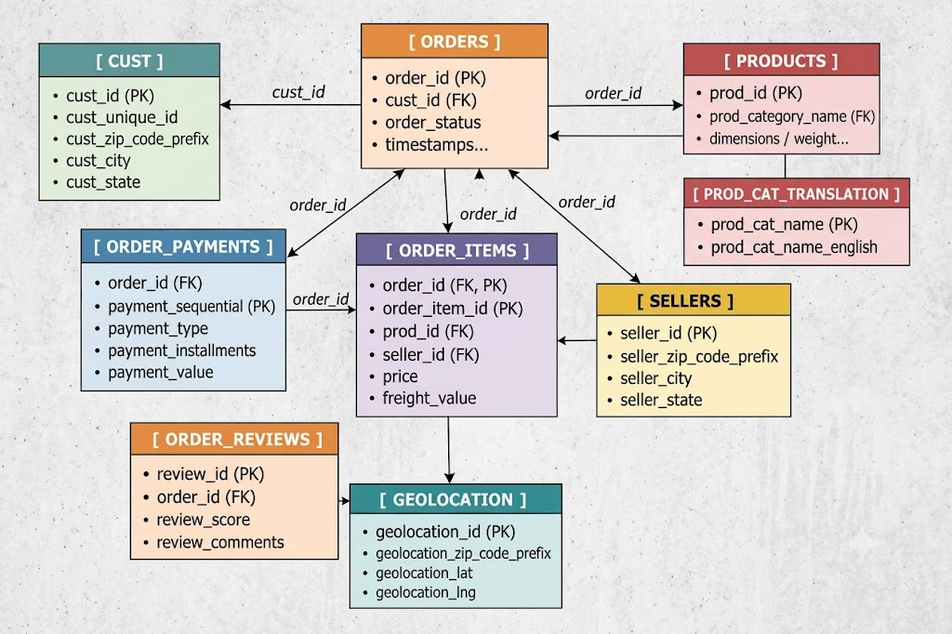
2. The Relational Data Architecture
The Olist dataset consists of 9 interconnected tables. Unlike flat data files, this star/snowflake-adjacent schema requires strict relational integrity.
Here is how the tables connect logically around the central core:
- olist_orders_dataset is the central hub of the entire database.
- Customers link to orders via customer_id.
- Payments and reviews link directly to order_id.
- Items inside an order map out the actual products (product_id) and the merchants (seller_id) fulfilling them.
3. The Data Flow & Mind Map
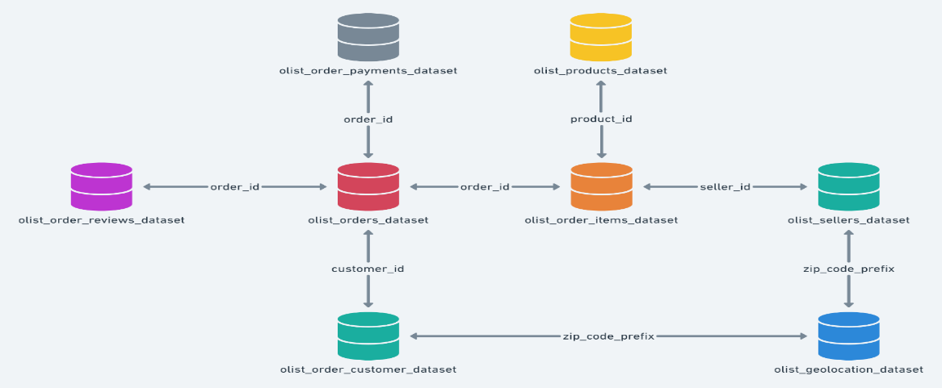
To map this database out in your mind, think of it in three logical layers centered entirely around the Orders hub:
The Transaction Core : olist_orders (the central anchor), olist_order_items (the cart contents), and olist_order_payments (the financial logs).
- The Entities : olist_customers (the buyers), olist_sellers (the merchants), and olist_products (the catalog).
- The Context & Feedback : olist_order_reviews (customer satisfaction), olist_geolocation (spatial coordinates), and product_category_name_translation (English labels).
3. In-Depth Table & Attribute Dictionary
Let's break down every single table, assigning exact MySQL data types and defining their roles as Primary Keys (PK) or Foreign Keys (FK).
Table 1: olist_orders_dataset
- Role: The transaction engine. Tracks the absolute lifecycle and timestamp history of every single order.
Column Name | MySQL Data Type | Key Type | Business Description & Constraints
order_id | VARCHAR(32) | PK | Unique alphanumeric identifier for each distinct order.
customer_id | VARCHAR(32) | FK | Points to olist_customers_dataset. Note: This changes per order.
order_status | VARCHAR(20) | None | Current state: delivered, shipped, canceled, invoiced, processing.
order_purchase_timestamp | TIMESTAMP | None | The exact date and time the customer placed the order.
order_approved_at | TIMESTAMP | None | Timestamp when the payment gateway cleared the transaction.
order_delivered_carrier_date | TIMESTAMP | None | Timestamp when the seller handed the package to the logistics carrier.
order_delivered_customer_date | TIMESTAMP | None | The actual delivery timestamp at the customer's doorstep.
order_estimated_delivery_date | TIMESTAMP | None | The original delivery date promised to the customer at checkout.

Table 2: olist_order_items_dataset
- Role: The manifest table. Since an order can contain multiple items from different sellers, this table breaks down the contents of each cart.
Column Name | MySQL Data Type | Key Type | Business Description & Constraints
order_id | VARCHAR(32) | FK | Links back to the central olist_orders_dataset.
order_item_id | INT | None | Sequential number identifying lines within the same order (e.g., 1, 2, 3).
product_id | VARCHAR(32) | FK | Links to olist_products_dataset.
seller_id | VARCHAR(32) | FK | Links to olist_sellers_dataset.
shipping_limit_date | TIMESTAMP | None | The seller's strict deadline to hand the product over to the carrier.
price | DECIMAL(10,2) | None | Item cost exclude shipping fees (in Brazilian Real, BRL).
freight_value | DECIMAL(10,2) | None | The shipping cost assigned to this specific item.

Table 3: olist_order_payments_dataset
- Role: Financial logs. Captures how customers settled their bills. An order can be split across multiple payment methods (e.g., part voucher, part credit card).
Column Name | MySQL Data Type | Key Type | Business Description & Constraints
order_id | VARCHAR(32) | FK | Links to olist_orders_dataset.
payment_sequential | INT | None | Sequence if a customer utilizes multiple payment methods for one order.
payment_type | VARCHAR(20) | None | Methods: credit_card, boleto (bank slip), voucher, debit_card.
payment_installments | INT | None | Number of monthly installments chosen by the customer (common in Brazil).
payment_value | DECIMAL(10,2) | None | The total amount charged to this specific payment line.

Table 4: olist_order_reviews_dataset
- Role: Customer feedback. Tracks customer satisfaction scores and textual critiques.
Column Name | MySQL Data Type | Key Type | Business Description & Constraints
review_id | VARCHAR(32) | PK | Unique identifier for the customer review submission.
order_id | VARCHAR(32) | FK | Links directly to olist_orders_dataset.
review_score | INT | None | Customer rating scaled strictly from 1 (worst) to 5 (best).
review_comment_title | VARCHAR(100) | None | Heading text left by the consumer (often empty/null).
review_comment_message | TEXT | None | Detailed textual feedback left by the user (often empty/null).
review_creation_date | TIMESTAMP | None | Timestamp when the review survey invitation was generated.
review_answer_timestamp | TIMESTAMP | None | Exact timestamp when the customer submitted their final review score.
Table 5: olist_customers_dataset
- Role: User demographics. Crucial note: Olist generates a temporary customer_id for every unique order instance, but tracks the actual human via customer_unique_id.
Column Name | MySQL Data Type | Key Type | Business Description & Constraints
customer_id | VARCHAR(32) | PK | The temporary handle used to bind a specific checkout event to an order.
customer_unique_id | VARCHAR(32) | None | The permanent, immutable ID of the actual customer (used for retention tracking).
customer_zip_code_prefix | INT | FK | First 5 digits of the Brazilian zip code. Links to olist_geolocation_dataset.
customer_city | VARCHAR(50) | None | City name where the customer resides.
customer_state | CHAR(2) | None | Two-letter state abbreviation (e.g., SP, RJ, MG).

Table 6: olist_sellers_dataset
- Role: Merchant registry. Contains location indicators for the supply-side partners.
Column Name | MySQL Data Type | Key Type | Business Description & Constraints
seller_id | VARCHAR(32) | PK | Unique code assigned to an Olist-registered merchant.
seller_zip_code_prefix | INT | FK | First 5 digits of the seller's zip code. Links to olist_geolocation_dataset.
seller_city | VARCHAR(50) | None | City name where the seller warehouse is located.
seller_state | CHAR(2) | None | Two-letter state abbreviation.

Table 7: olist_products_dataset
- Role: The item master catalog. Houses structural metadata for every product.
Column Name | MySQL Data Type | Key Type | Business Description & Constraints
product_id | VARCHAR(32) | PK | Unique alphanumeric code for a catalog item.
product_category_name | VARCHAR(50) | FK | Product group name written in Portuguese.
product_name_lenght | INT | None | Character count of the product name text.
product_description_lenght | INT | None | Character count of the product description copy.
product_photos_qty | INT | None | Total number of images published on the item listing.
product_weight_g | INT | None | Product mass registered in grams.
product_length_cm | INT | None | Item package length in centimeters.
product_height_cm | INT | None | Item package height in centimeters.
product_width_cm | INT | None | Item package width in centimeters.

Table 8: olist_geolocation_dataset
- Role: Spatial reference database. Resolves zip codes into coordinate nodes for physical mapping.
Column Name | MySQL Data Type | Key Type | Business Description & Constraints
geolocation_zip_code_prefix | INT | None | First 5 digits of the localized zip code network.
geolocation_lat | DECIMAL(10,8) | None | Latitude coordinate tracking point.
geolocation_lng | DECIMAL(10,8) | None | Longitude coordinate tracking point.
geolocation_city | VARCHAR(50) | None | Standardized local city reference.
geolocation_state | CHAR(2) | None | Local state region code.

Table 9: product_category_name_translation
- Role: Localizer mapping. A simple lookup matrix translating Portuguese classifications into English for cleaner frontend UI rendering.
Column Name | MySQL Data Type | Key Type | Business Description & Constraints
product_category_name | VARCHAR(50) | PK | Original category string in Portuguese.
product_category_name_english | VARCHAR(50) | None | Corresponding clean English translation string.

